Trends of Soft Drinks in Thailand

Warayut Muknumporn

([Wm2n21@soton.ac.uk](mailto:Wm2n21@soton.ac.uk)/32314914)

# Data Story Summary

[1] The beverage market is one of Thailand's most significant volume trading markets, and it is still growing. So, what are the driving forces behind the beverage industry's expansion? The beverage market is separated into two distinct segments according to the data. There are two types of beverages: alcoholic drinks and non-alcoholic drinks. With an average market share of 82 percent for non-alcoholic Drinks and 18 percent for alcoholic drinks. This means that non-alcoholic drinks dominate most of the beverage market.

What's more interesting is that the non-alcoholic beverage market may be split into two categories: hot drinks and soft drinks. Soft drinks have a 95 percent /5 percent market share in the non-alcoholic drinks market. Soft drinks have a far larger market share than other beverages and are expected to continue to expand year after year. To answer the question "What is the significant contribution to the total consumption ?"

Soft drinks have the most significant market share in the beverage market, as can be seen from the graph above.

Soft Drink Trends is a key component that can be answered from the data story. It is a leading predictor of the beverage market's direction. as a result of that data's analysis, [2] This suggests that the Soft drinks market trend is influenced by three primary factors:

* People are more interested in healthy beverages;
* In 2017, Thailand increased its sugar tariff. causing more sugar-free or low-sugar goods to be released
* People's attitudes have shifted as a result of Covid. as well as forcing the market's growth rate to plummet in 2020

Market trends are important to know and understand. This opens up the new business potential for players or producers. whether to adapt the launch of new products or marketing to reach the customer target group

# Dataset Summary

All of the data set is from Euromonitor International [3] and supports the story outline. All of the Dataset is provided with the data from 2010 to 2021. Each data set will describe in the topic below:

1. Information on Alcoholic Drinks

This data collection depicts the state of the alcohol Drinks, Such as the annual volume and value of the alcohol market and Various types of alcoholic drinks. To prepare this data, the total trading volume was selected compared to non-alcoholic beverages.

1. Information on Non-Alcoholic Drinks

This dataset provides an overview of the non-alcoholic beverage market. For example, the quantity and value of the non-alcoholic market each year and there are two types of non-alcoholic beverages:

* 1. Hot Drinks:

For this dataset, there are several types of hot drinks. This includes estimating the volume and value of this type of market each year. For cleaning this data, to get the market share of non-alcoholic beverages, aggregate data were taken from market share action with soft drinks

* 1. Soft Drinks:

For this batch of data, It has been accorded the highest priority. In this data collection, soft drinks are classified into eight categories, with each category broken into three sub-categories. Each year, to observe the variances and gain access to significant aspects affecting each product's trend, as well as transaction statistics. Getting this data set ready to see the market trends each year, the data is divided down into each product category. It separates the categories of trading into Retail(on-trade) and food service (off-trade), for example, to examine the impact of COVID-19 for discovering product type trends by calculating growth rate per year. It has delved into the many sorts of beverages in order to identify market trends and discover healthy drinks. Analyse the data to spot patterns. Analyse to see trends in addition to exploring the type of low-sugar or no-sugar beverages to find out the impact of the 2017 sugar tax increase law in Thailand.

For all of the dataset types. They all group together by using Years. to compare and see the differences of each type of data

# Visualisations

From visualisation in HTML file. It uses the command to retrieve data from tableau public. The displayed image will display the title, the number of pages to choose from by click to view for the convenience of browsing the data and having the option to specify the year to expand the information in that year more clearly. The size of page and image is adjusted automation of each screen size monitor.

## Expanding on the importance of data analysis in the soft drink market. Visualisation 1

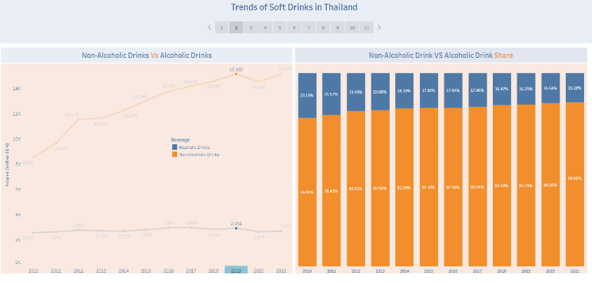

Figure 1: beverage market trends and total market share

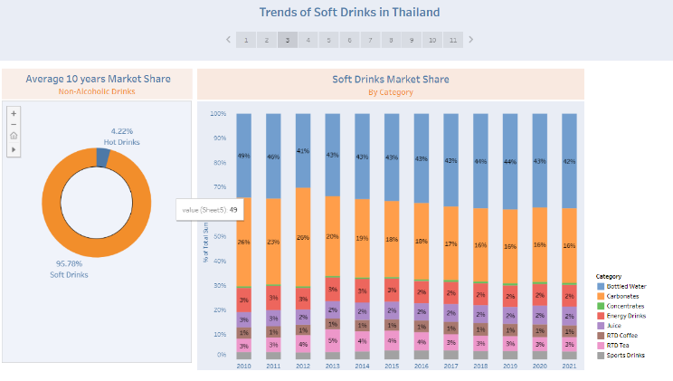

Figure 2: Expand the non-alcoholic beverage category and focus on soft drinks.

### Description

this visualization shows an overview of the domestic beverage market to demonstrate that the market share is clearly different and narrows the data into the non-alcoholic drink market by Figure 1.

Then in Figure 2. This second page of visualization shows types of non-alcoholic beverages using a pie chart and looking at the average market share in Ten years ago to narrow down to do soft drink with the highest market share Then categorize soft drink. by using a bar chart to analyze the market share to find the true market leader of all beverages

### Justification

In each visualization. Represents market data using trading volume and year for comparison. Then bring to show the market share to show the clarity of dominance throughout the beverage. and enabling it to correctly focus on the key points of its significance that will have an impact on the beverage market

### Narrative Design Patterns

Narrative design patterns of this visualisation are use compare, drink of the same type Demonstrates a clear divergence of traded volumes to focus on the largest segment.

### Strengths and Weaknesses

The strengths of this visualization are the use of narrative design patterns, clarity, and rational focus on goals. It clearly shows the difference in market share and is a reason to focus on the soft-drink market. The downside is that it cannot show the details of drinks in other out-of-focus categories.

### Improvements

Look for a way to include some description in the visualization. It will allow audiences to gain additional insight from the data.

## Focus on the beverage category with the largest market share of Soft drink Visualisation 2

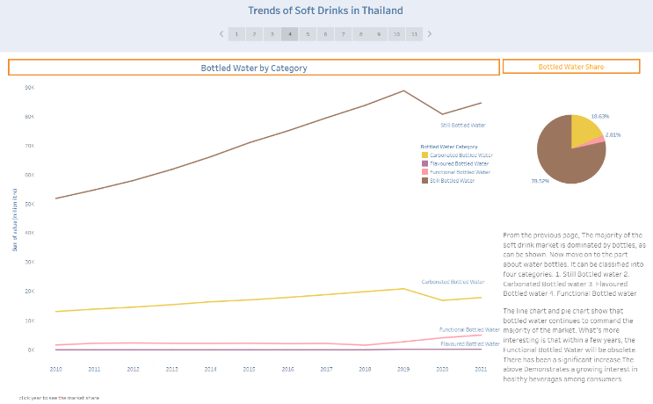 Figure 3: Expanding the key areas of the soft drink with the highest market share

### Description

Figure 3. The soft drink market leader's complete information is displayed. To discuss the importance of the elements in soft drinking, The data illustrates the annual trading volume and market share of each type of bottled water drinks.

### Justification

In figure 3, focus on the type of bottled water. To find out why it is important. The line chart shows the trading volume, gives a glimpse of the market trends over the past ten years, and the pie chart shows the resulting market share to see the importance of each type of bottled beverage.

### Narrative Design Patterns

The narrative design patterns of this visualization show the trends that have occurred in the past few years. The data shows an increase in the market share of "functional bottled water" despite the impact of the COVID-19 pandemic.

### Strengths and Weaknesses

The strength of this chart is that it shows the data clearly and how it differs from other data sets. This visualization Year can be selected to display each year's market share in a pie chart. The weak point of this visualization is the Inability to display information on other types of soft drinks.

### Improvements

Find a strategy to incorporate the remaining soft drink types. to be able to view the information more clearly and with greater curiosity

## Focus on Healthy trends Visualisation 3

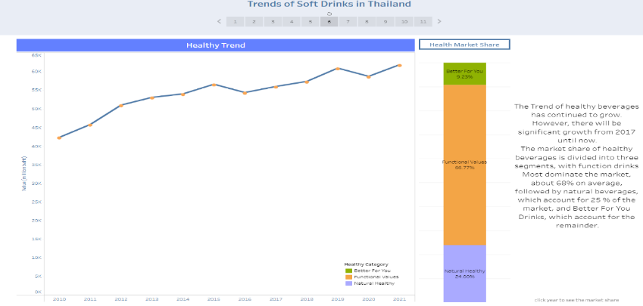

Figure 4: Healthy Trend

### Description

The trend of the health drink market, which is constantly rising, is depicted in this picture. With a choice year to display, the line chart shows the annual market value and the bar chart shows the market share of healthy beverages.

### Justification

In Figure 4, the trend of healthy beverages continues to grow, which is a good trend in the soft drink category. So it makes sense to focus on what types of healthy beverages are available and to find out the significance of the drivers of this trend.

### Narrative Design Patterns

This Narrative Design pattern represents a limiting of the content to identify the market's primary topics and trends.

This illustration depicts the features of each year's wings' features to demonstrate and explain shifting tendencies. better customer behaviour

### Strengths and Weaknesses

The advantage of this visualization is A clear representation of the trend of healthy beverages. This shows that nowadays people are more conscious about their health. The bar chart shows difference in market share from year to year. The disadvantage is that it is unable to display data on other trends occurring in soft drinks.

### Improvements

Find a way to include a second chart to provide more detail of the other trends, both positive and negative. such that the details are not all pointing in the same direction

## Expanding information on health drink trend visualization 4

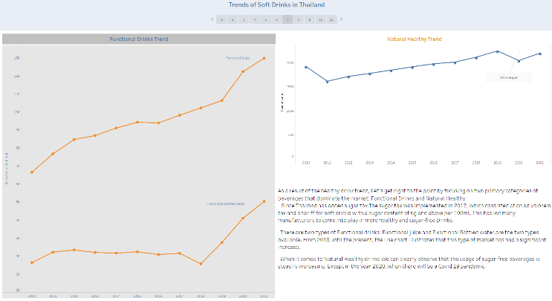

Figure 5: Expanding key information on Healthy trends



Figure 6: Rhetorical question pattern of visualization 3,4

### Description

Functional Drinks Trend and Natural Healthy Trend are the two forms of healthy beverages highlighted in Figure 5. The chart clearly shows the changing trends in healthy beverages, something that happened in 2018.

### Justification

This visualization It is a perfect fit for a chart like this one as it can clearly see the changing trends in 2018. Moreover, saw a markedly positive trend in healthy beverages.

It is essential to indicate that the trend direction is correct in the data. The reason for using three separate graphs is that they want to show the different trends in the health drink market clearly.

### Narrative Design Patterns

This visualisation begins with a rhetorical question pattern [4] to make audiences argumentation and more engagement its stories in the visualisation as shown in Fig. 4 and Fig.5. Moreover, concretise pattern [4] has been added to the visualisation by showing. This Narrative Design pattern effectively conveys crucial information regarding Thailand's sugar tax increase. There was a comparison of the model's metamorphosis since they saw the difference in the legislation. The manufacturer's latest product, which focuses on low-sugar and sugar-free beverages.

### Strengths and Weaknesses

The advantages of this visualization It represents a trend that has clearly changed. consistent with the information obtained The disadvantage is that it can display less information and is not as detailed as other types of information.

### Improvements

Find another way to display data or charts. Add interesting functions and expand information including other types of beverages that are affected by Thailand's sugar tax increase.

## Show the impact of covid 19 on the soft drink market. visualization 5

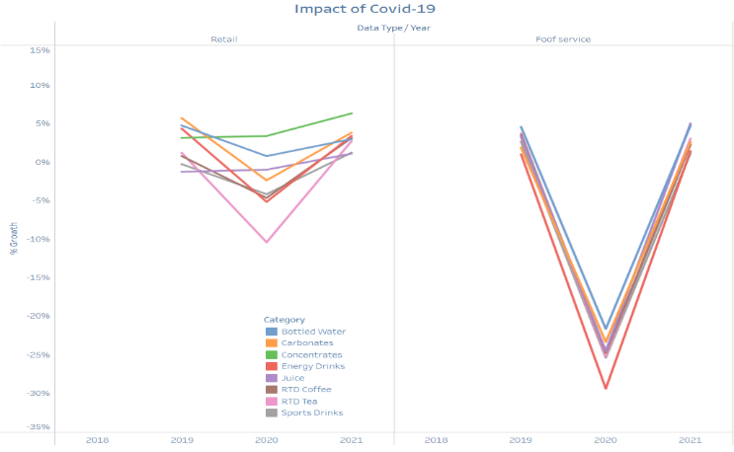

Figure 6: Line chart showing the impact of COVID on soft drinks using market growth rates. visualization 5

### Description

The percentage of soft drink growth significantly decreased in 2020, as shown in the graph Figure 6. The market impact will be classified into two parts: Retail and Food service.

### Justification

this illustration It clearly demonstrates COVID's impact. By comparing the growth rates of various types of beverages from 2019 to 2021, the period of the outbreak, both before and after the first wave of coronavirus.

### Narrative Design Patterns

The differences that have occurred during the COVID-19 epidemic are well illustrated in these Narrative Design Patterns. To emphasize the disparities and shifting behaviour of customers as a result of Thailand's anti-COVID legislation, there are two forms of beverage trade.

### Strengths and Weaknesses

The chart's advantages reveal a stark contrast between Covid's impact on the soft drink market before and after.

The negative is that you won't be able to concentrate on other years. It's unique to the year the coronavirus was discovered.

### Improvements

Extend the year to display the beverage category. Increase the function of accessing more information and additional details to solve the covid problem.

## Expanded key data of the soft drink category with a positive growth rate. visualization 6

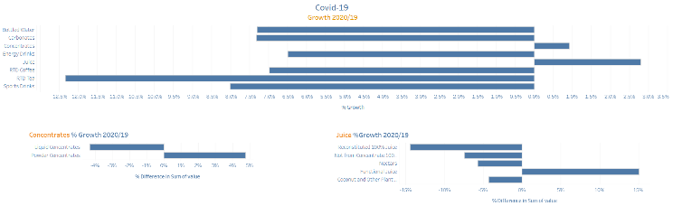

Figure 7: Bar chart for soft drink type focusing on growth rate.

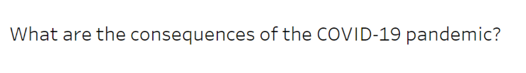

Figure 8: Rhetorical question pattern of visualization 5,6

### Description

The bar chart shows the 2019/2020 growth rate of the soft-drink type and expands to the positive-growth soft-drink type.

### Justification

this visualization It represents behaviours that have changed during the coronavirus and the trends that have taken place are important enough to sustain the growth rate of those beverages despite the coronavirus crisis. The division into 3 charts To illustrate the data more clearly by expanding to each type of data that is important to the soft drink market during the Covid It shows the behaviour and trends of the market as well.

### Narrative Design Patterns

From Figure 8, the question is used to start the issue to be discussed [4]. And invites the reader to be more interested in the topic, causing empathy or a feeling of curiosity about what is going on. this Narrative Design Patterns. Figure 7 shows a specific beverage growth rate data that shows positive growth during COVID. To clearly differentiate what happened during the epidemic. How do consumers behave?

### Strengths and Weaknesses

The benefit of exhibiting a chart like this is that the differences between beverage types and people's behaviour during the COVID-19 pandemic can be readily seen.

The downside is that people's behaviour prior to the Covid-19 period is not visible.

### Improvements

Show more years to see consumer behaviour in the pre-Covid period. and add a function to browse information.

# Conclusion

# This data narrative focuses on soft drinks and includes information, significance, and trends in the beverage business because soft drinks have the highest turnover of any beverage category. Because of this visualization, describe the rationale for focusing on the soft drink market and the market's importance, impact, and incidents. Knowing the trends and their impact on the market is critical in assisting producers in properly adjusting or launching new items and reaching consumers.

# References

1. Beverage Industry Outlook 2017-2021: Beverage Industry. Available: https://www.krungsri.com/en/research/industry/industry-outlook/Food-Beverage/Beverage/IO/io-beverage-20-th [Accessed November, 20 2021].
2. Going beyond immunity: Thai beverage manufacturers cash in on beauty and wellness By Globaldata consumer [Online]. Available: https://www.drinks-insight-network.com/comment/thai-beverage-beauty-wellness/ [Accessed July 9 2021].
3. Soft Drinks in Thailand Data | MARKET DATA. [Online]. Available: https://www.euromonitor.com/soft-drinks-in-thailand/report [Accessed November, 20 2021].
4. B. Bach, M. Stefaner, J. Boy, S. Drucker, L. Bartram, J. Wood, P. Ciuccarelli, Y. Engehardt, U. Köppen, and B Tversky. “Narrative design patterns for data-driven storytelling.” In Data-Driven Storytelling, N. H. Riche, C. Hurter, N. Diakopoulos, and S. Carpendale, Eds. CRC Press, USA, 2018, ch. 5, pp. 107–134. <https://research.utwente.nl/en/publications/narrative-design-patterns-for-data-driven-storytelling>.